Problem Statement
EU SARG will empower EU MMN with a cutting-edge, web-based tool that revolutionizes the way workforce scheduling and assignment are managed. The priority is to ensure a seamless integration of SARG with the unique operational landscapes of EU sort centers recognizing the diversity in scheduling practices, regulatory requirements, workforce management structures and ensuring compliance with local regulations. The specific focus is put on designing SARG to be scalable and extensible, accommodating the evolving needs of EU5 sort centers and integration with existing and new upstream & downstream systems in the quickly evolving Labor Planning & Allocation & Assignment product landscape.

Software Commitment
2024 SARG Expansion to UK P1 Release. EU Science and Tech will start campaign work on February 5th. NA Kepler Tech will begin campaign work in early March after they first complete an in-progress campaign. Kepler Tech and EU Science & Tech are committed to the following timelines:

Complete developer work: August 2nd, 2024
Complete QA Testing: August 23rd, 2024
Production Ready: August 26th, 2024

Software Development Plan
Kepler Tech and EU Science and Tech will release UK/EU SARG MVP requirements in one release. Due to the complexity of this campaign, SDEs will build both Backend and Frontend components in parallel. The following below provides a high-level scope of work that is planned for this release. Unit, developer and integration testing is required once scope of work is complete before Quality Assurance (QA) and User Acceptance Testing (UAT) can begin.

Sprint Planning and Grooming
Kepler Tech and EU Science and Tech teams will have joined Sprint Grooming sessions bi-weekly. This will ensure 1) SDEs know which tasks are required to be complete per sprint 2) reduce duplication and churn of tasks 3) provide consistent updates to Product owners. Once sprints are planned, each team will manage their sprints independently. Bi-Weekly Product Health Sync Updates are currently scheduled and run by Product owners (we will transition to weekly health syncs 4 weeks out from developer complete date or if campaign becomes unhealthy at any time).

Host Team and Away Team Model
Kepler Tech and EU Science and Tech teams will utilize a Host Team / Away Team model (Appendix E – Host Team Away Team Model) as a best practice. Kepler Tech (Host Team) will own and make core backend services for SARG extendable for EU Science and Tech team (Away Team) to consume. This includes making shared front-end libraries consumable. EU Science and Tech team will own dependency ingestion, regional use case features (applies to both frontend and backend APIs) and frontend code packages with a newly provisioned endpoint. This model enables the EU team to 1) scale more seamlessly 2) respond faster to severity escalations 3) have a more independent roadmap and timeline to deliver regional features. Not having to wait for NA pipelines and deployment windows is more ideal.

External Data Ingestion

EU Science & Tech Team

Clone NA Umbrella LMS Ingestion in EU (Andes) – Kepler Tech will provide EU Science and Tech with HLD and LLDs so that Umbrella LMS Ingestion can be replicated for UK/EU. This is required so SARG can provide Operations with visibility to whom is trained and not trained per process path. Once built, modify code to integrate EU Umbrella LMS Ingestion S3 buckets.

Shift Plan Ingestion – Build an ingestion pipeline for EU Ready data.

Employee Data (Andes) – Build employee data ingestion pipeline. Send data to SARG EU region DynamoDB. Reference NA Employee Data schema structure.

Site Information Ingestion – Update Configuration API with required list of active sites and its metadata for the Config API’s DynamoDB table in EU hosted zone.

Consume/Verify EU PPA Aggregates Ingestion – Once Kepler Tech replicates PPA Aggregates Ingestion, EU Science and Tech will assume immediate ownership. Kepler Tech will provide a knowledge transfer so EU Science and Tech can maintain data for the foreseeable future. This may also require BI support if this data requires QuickSight reporting. Once built, modify code to integrate with EU Umbrella LMS Ingestion S3 buckets.

NA Kepler Tech Team

Add EU Region to PPA Aggregates Pipeline – Code change required to pull active node ids for EU from Config API. Create new AWS Account in EU hosted zone. In existing ATSquadPPAIngestion Pipeline, add EU Account and deploy PPA Ingestion.

Knowledge Transfer – NA Kepler Tech will provide full knowledge transfer which includes: all relatable documentation, codebase overview, Configuration API, RO-GR API, Planning API, Frontend, LMS Ingestion, PPA Ingestion, Interactive sessions and feedback lops.

Backend Domains

EU Science & Tech Team

Build Shift Configuration API, Lambdas and S3 – Build backend that will support Shift Configuration functionality and data store. Integrate with backend to properly create Shift Plans by Shift Code. Support CRUD operations to manage and map multiple shifts to Sort Groups.

Create SNS Topics for EU BI Teams to consume – Import and modify code to integrate new SNS topics for EU BI teams to consume and create QuickSight reports.

Modify Roster Upload API – Add additional columns and implement logic defined from Product team.

Add EU Ready Synchronization – Build API to GET shift and associate metadata from EU Ready Ingestion. Transform EU Ready data with Employee data from excel upload.

Publisher Workflow – Modify workflow to listen for event notification when the Planning API stores shift plan in an S3 bucket. Coding is needed to support EU specific steps within step functions to call necessary APIs (Shift Plan) to generate data required to call RO-GR API with shift data to generate an associate roster.

NA Kepler Tech Team

Deploy Planning/Templating APIs to EU Region – Create new AWS Account in EU hosted zone. Modify publisher code. Access Route53 service to update hosted zone for EU. In existing PulsePlanning API Pipeline, add EU Account and deploy Planning/Templating API code.

Deploy Configuration API to EU Region – Create new AWS Account in EU hosted zone. In existing PulseConfiguration Pipeline, add EU Account and deploy Configuration API. Access Route53 service to update hosted zone for EU. Ensure CDK scripts are configured to target EU hosted zone.

Deploy Roster Generator (ROGR) to EU Region – Create new AWS Account in EU hosted zone. In existing PulseRosterGenerator Pipeline, add EU Account and deploy ROGR. Ensure CDK scripts are configured to target EU hosted zone. Access Route53 service to update hosted zone for EU. Modify architecture to enable ROGR to directly interest with LMS certificates during auto roster assignment process.

Integrate Fast Start S3 Buckets – This is required when publishing rosters. Fast Start reads published rosters from its own designated S3 buckets. Update Fast Start configuration to subscribe to newly created S3 buckets in ROGR account.

Relocate Roster Upload API (Move from Fast Start to EU SARG) – Import and modify code from Fast Start to SARG EU Front End code package. Hide existing code to upload roster in Fast Start. Verify upload functionality is working. A deployment to Fast Start is required.

Frontend

EU Science & Tech Team

Create new Code Package, Pipeline and Provisioned Endpoint – Create new code package, new EU pipeline to deploy the front end and a new provisioned endpoint. This is required enable to maintain Data Privacy standards and support unique regional feature enhancements.

Consume Front End Libraries – Consume PSP and SARG library files that are now available and extendable from NA Kepler Tech team.

Customize Node Configuration UI – Front end will have to use filter to display UI based on sort group. It’s required to call getSortGroups (new API) to display list of SortGroups for EU. When a user selects active process path for a sort group, it needs to update associate shift field with the new sort group.

Restrict Templating with LDAP – Restrict access to templating page with LDAP. We will also need to handle node level access (authorization).

Build Shift Configuration UI – This is a new module that will be added to Pulse Shift Planners configuration. This module allows operations the ability select unique cohorts and group them by a sort name. This shall enable the ability to define start and end times per shift.

Clone and Modify SARG UI – Import SARG UI code and integrate within new front end code package. Verify users are able to perform all rostering functionality (view, assign, drag and drop, LMS Time in Path, save, edit, publish etc.)

Clone / Modify Shift Plan (PSP Lite) – Import code to create a modified version of PSP (Shift Plan landing page, shift plan input page). Hide volume totals but allows users to input headcount required by process path. Verify PSP Lite allows users to create, copy, publish and modify shift plans.

NA Kepler Tech Team

Fast Start, Hide Excel Upload for Exempted Sites – Provide a front-end solution to hide the upload excel option in Fast Start for sites that are using both SARG and Fast Start vs Fast Start independently.

Clone Templating, Node Configuration UIs – Import code and integrate. Perform developer tests to verify functionality is working properly.

Infrastructure Component Diagram with Noteworthy Mentions
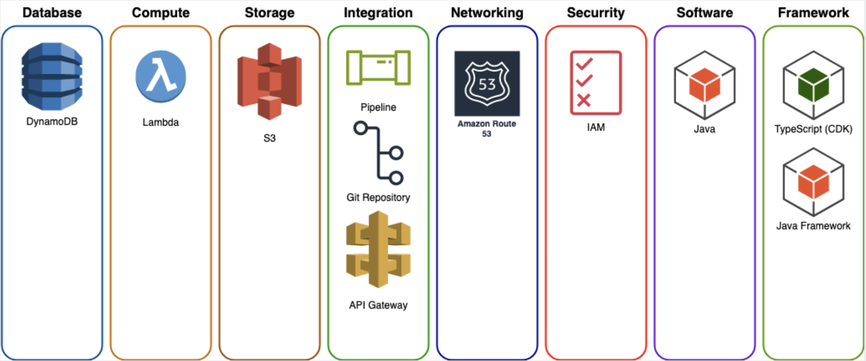

Security (AuthN, AuthZ)
All proposed software designs will meet InfoSec (Amazon Security Review, ASR) and Data Privacy (Kale) Standards.

Midway Authentication - NextGen Midway is the SSO authentication (AuthN) system based on strong cryptography. It delivers a completely redesigned implementation of the Midway authentication system with new hardware tokens, a single-sign-on user experience, and a new enrollment and management infrastructure - all with the same high security. Pulse already uses Midway for AuthN and will continue to do so.

IAM Roles – Used for Identify and Access Management, IAM roles will be used to manage backend authorization permission management.

Permissions Teams – Allows SDEs to create a team, group people and associate POSIX, LDAP, ANT groups to that team. Teams provide authorization permission management for Front End users.

Compute

Lambda - While AWS Lambda will be used to process and compute events at different stages of a predefined workflow, supporting PPA and LMS ingestion and data aggregation. Lambda is also utilized for Pulse Roster Generator logic. No concerns with Lambdas compute or memory for task execution in Kepler Techs current design for North American Sort Centers which currently supports 115 warehouses.

Database & Storage

Dynamo DB w/ S3 Buckets – A hybrid approach was chosen for data storage. Shift Plans and Rosters are stored as objects currently so continuing to utilize S3 Buckets to limit disruption for downstream services made sense. Storing different components of a Node Configuration, Dynamo DB can support faster access at the time of editing and reduce delays by avoiding object level writing and over-writing on the same object again and again.

Integration Accessibility & Data Vending

API Gateway – Ideal for creating, publishing, maintaining, monitoring and securing APIs at scale. Multiple APIs are in scope to support Front End and Backend Requests.

SNS Topics and SQS Queues – Both are sufficient for data vending purposes. This is standard for most applications built in Native AWS (NAWS). SQS and SNS is required so BI-Teams can subscribe to available SNS Topics to ingest data and provide data accessibility and reporting solutions like QuickSight.

Security and Data Privacy Review
EU Science and Tech will need to submit a new Amazon Security Review since there is a change in the current infrastructure design for SARG. SARG is currently approved for production deployment to all UK/EU sites that do not have a work council. Privacy Review for SARG can be found here. Data dictionary review for SARG can be found here.

Software Testing and Integration

System Integration / QA Testing with SARG and Fast Start
The plan is to leverage Quality Assurance (QA) accounts to do QA and Business Logic testing. SDEs will execute end-to-end system testing (unit testing included) before pushing code to QA stages. A low-level design is required enable to work out finer details around how QA testing will be supported. A joined LLD is required to define how Kepler Tech & EU Science and Tech plans to test QA environments for SARG and FastStart in the EU region.

Modeled Change Management (MCM)
NASC Tech is committed to following steps outlined in the Software Development Plan for managing MCMs. Those steps are:

- Service Level Agreement (SLA)
  - Standard SLA is 3 weeks for downstream consumers to test, verify and confirm all proposed Data Model Changes are ready for ingestion
  - Failure to do so can result in timeline delays data leaks, system outages etc.

- Approvers
  - All Quality Assurance Test Plan Owners / Execution owners
    - Julia Smirnova – Sr. PMT
    - Charly Schmidt – MFO Expert, UTR Flow, ATS ACES
    - Dhruvi Sinha – Sr. PM
  - All downstream service owners shall be identified and added as approvers
    - Nitin Goyal – Data Engineering Manager
  - All Product owners and Business Stakeholders shall be added as approvers
    - Julia Smirnova – Sr. PMT
    - Ulrich Bombka – Sr. PMT
    - Dhruvi Sinha – Sr. PM
    - Mike Feldman – Principal PM
  - All Tech owners shall be added as approvers
    - Hyung Lee – SDM
    - Guilhem Busset - SDM
    - James ODonnell – Sr. TPM
    - Hari Vijayaraghavan – Sr. Manager, SDM

- Creating an MCM
  - The MCM will be owned by the Lead SDE assigned (Requestor)
  - Lead SDE will use MCM Portal to create and manage all MCMs
  - For scheduling, lead SDE shall use the proposed QA window as the proposed MCM window.
  - Lead SDE shall identify all affected services and owners and communicate timelines to those affected service owners within each MCM. TPM/SDM communicates timelines to those affected service owners within each SDP.
  - Each MCM required shall be created during the first sprint of a campaign build to inform downstream consumers
  - Lead SDE is responsible to ensure a Disaster Recovery Plan is defined for each MCM
  - Lead SDE is required to escalate immediately in the event a deployment is identified as non-backwards compatible blocking the ability to rollback a deployment in the event of a failure.

Product Release Plan
A Product Release plan shall be owned by EU Science and Tech. This plan is expected to be defined/presented after BRD/SDP is locked. The release plan shall capture the following high-level requirements:

- Pre-Requirements (QA Accounts etc) for testing
- QA Test Cases, Bug Fixes and Timeline
- QA Sign Off Dates
- MCM Sign off Dates
- Final Go / No Go Meeting
- Production Release Date
- Go to Market Site Launch Plan (All at once, in waves etc.)

Risks and known Headwinds
The following risks and known headwinds have been identified. High risk indicates a blocker that will impact projected production timelines.

(Blocker) Employee Profile Table (In-Progress)
This will impact aggregation for LMS Ingestion pipeline. Due to EU Data Privacy requirements, attributes like employee id are not available. This will require SDEs to deep diving to ensure mapping between LMS data and employee data can be properly joined; otherwise, proposed timelines will be at risk if significant deep diving to propose a solution is required.

(High) Managing LMS Data in EU Cluster (In-progress)
There is a plan to create a special cluster on EU ATS/DnA side however, it has been blocked by Global Talent Management Central team since 6 month (Privacy ticket: DTP-14996; same repository as all SIMS, key word HRPRP). The blocker is that EU ATS DnA is not part of PXT division comparing to the tech teams working on the LMS (GOLD) therefore, more specific procedure may be applied.

(High) Create and Adjust the Publisher Workflow within Planning API
EU Science and Tech will have to modify publisher workflow (remove SSPOT, employee table) and use EU Ready and an internal solve for employee data from Excel upload. This requires a new Low-Level Design and a build from scratch.

(High) Severity Support
Following the Host Team and Away Team model, each Tech Team shall own and provide Severity 2 (SEV2) support based on their defined ownership areas. If SEV2 support is not provided by either Tech Team, this could directly impact tool adoption and Operations confidence in using SARG as part of their daily standard work.

Medium) Allocated Headcount
Planned SDE headcount must remain fulfilled throughout the duration of the SARG UK Expansion campaign. Any reduction to allocated HC will have a direct impact to production timeline commitments. For NA Kepler Tech, 2 SDE’s minimum must be allocated. For EU Science and Tech, 1.5 SDEs minimum must be allocated per the Sprint Forecast.

(Medium) NDA Required to be signed for LMS
NDA is required to be signed and approved by L8 (Nick Posada) to work with datasets for worker council sites. This should not impact sites that do not have worker councils.

(Medium) Finalizing UX Design with BRD
A finalized UX Design is required and must be finalized along with BRD requirements. This is imperative to ensure an accurate software solution is produced. If a UX Design is not finalized in time, this will confuse SDE’s on which Front End components are required to be built. SDE’s will have to work backwards, continually refactor software designs which will not make proposed timelines achievable.

(Medium) Large Amount of Front-End Customization
Due to the amount of customization that is required, it’s possible that Front End customization requirements may be limited to secure the targeted September 1st 2024 need by launch date.

Engineering Estimates and Sprint Timelines
All proposed estimates below assume all data related blockers have been removed before work is scheduled for this project. We assume that all data requirements are defined in all related documents meaning clear and precise direction is given as to what each tool / feature shall look like, operate and provide data inputs and outputs. Any ambiguity that is identified after a design is approved will create longer lead times. All estimates provided do not include engineer vacation/sick time and are subject to change at any time including but not limited to: New Business Use Cases and Standard Work, Design Mockup Approval Delays, Complexity of the Design, Design Changes during Build Phases, Headcount Constraints, InfoSec Campaigns, Unforeseen Events (hardware failure, code patches etc.).

Sprint Forecast:
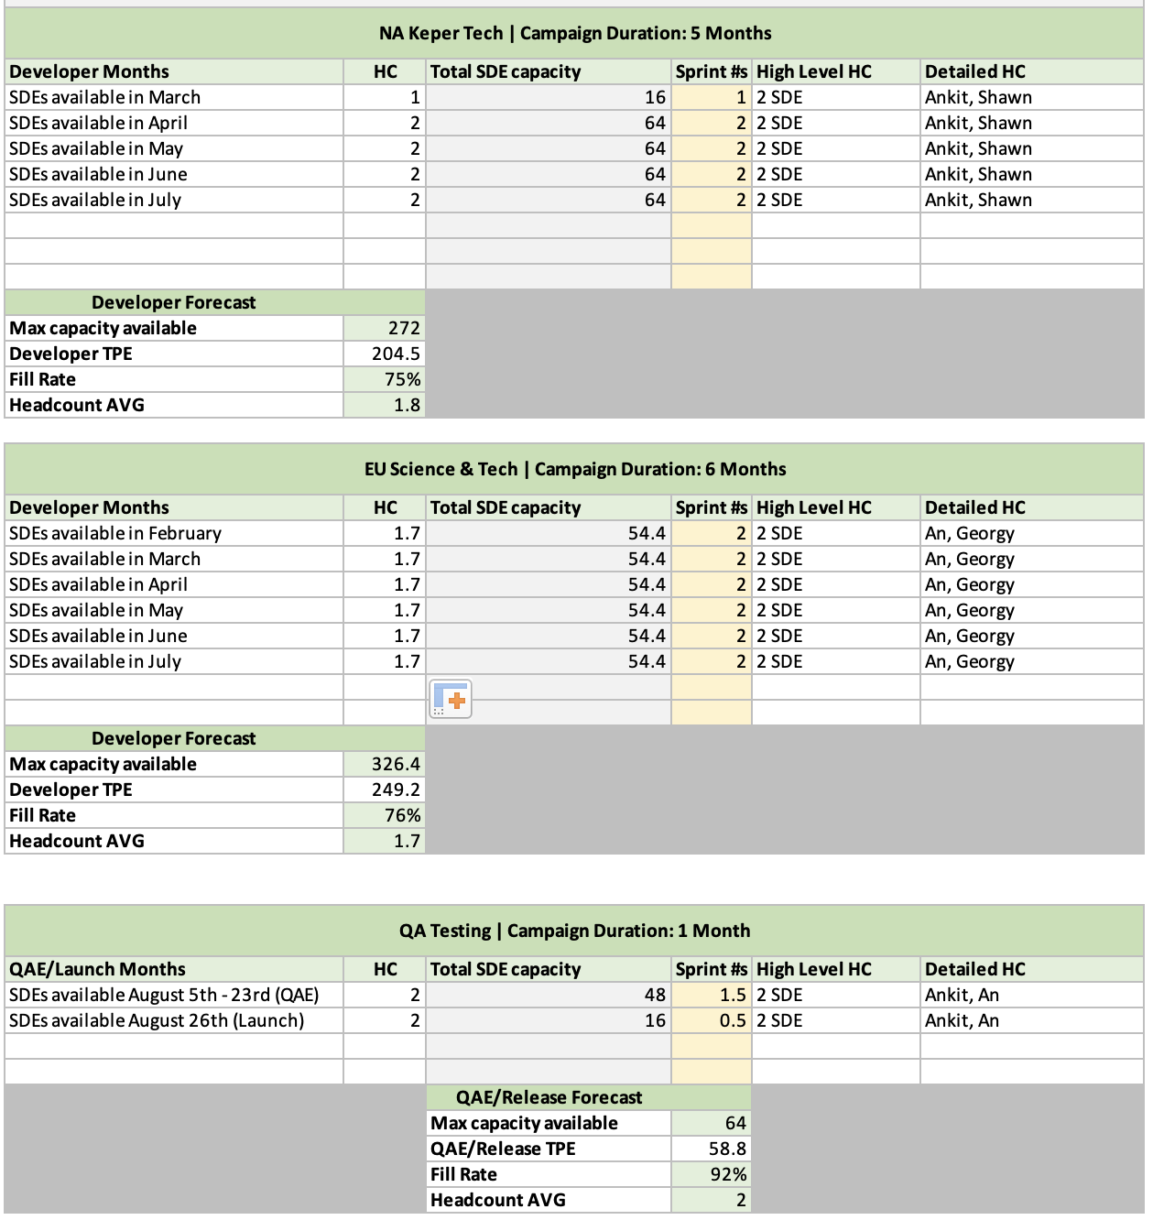

Build Estimates – NA Kepler Tech (Does not include QA or GTM)
High Level Task (Epics) | Development Task | Point Estimate | Slack Time | Task Point Estimate
Configuration API | Provision AWS account. | 1 | 1 | 1
Configuration API | To deploy to the EU region and update the Hosted Zone for EU to create an API Gateway domain, follow these steps:  • Deploy to EU Region: Ensure that your CDK scripts are configured to target the EU region. This may involve specifying the AWS region in your deployment command or script.  • Update Hosted Zone for EU:  Access the AWS Route 53 service to update the Hosted Zone for the EU region.  Create a new record set or update an existing one to configure the necessary settings for your API Gateway domain.  Associate the API Gateway endpoint or custom domain with the appropriate DNS records in the Hosted Zone. | 8 | 1 | 8
Configuration API | Disable Integration with ATS-BI's S3 Bucket (for EU only) instead Configure Integration with DynamoDB to pull active site information.  Testing:  • Thoroughly test the updated API to ensure that it successfully reads data from DynamoDB for the EU region and that the integration with ATS-BI's S3 bucket is disabled.  Documentation:  • Update any relevant documentation to reflect the changes in data source for the EU region. | 4 | 1 | 4
RO-GR API | Provision AWS account. | 1 | 1 | 1
RO-GR API | To deploy to the EU region and update the Hosted Zone for EU to create an API Gateway domain, follow these steps:  • Deploy to EU Region: Ensure that your CDK scripts are configured to target the EU region. This may involve specifying the AWS region in your deployment command or script.  • Update Hosted Zone for EU:  Access the AWS Route 53 service to update the Hosted Zone for the EU region.  Create a new record set or update an existing one to configure the necessary settings for your API Gateway domain.  Associate the API Gateway endpoint or custom domain with the appropriate DNS records in the Hosted Zone. | 16 | 1.1 | 17.6
RO-GR API | To enhance the interaction between RO-GR and LMS certificates during auto roster assignment and streamline the LMS training data handling, consider the following modifications:  Direct Interaction with LMS Certificates:  • Modify the current architecture to enable RO-GR to directly interact with LMS certificates during the auto roster assignment process.  LMS Data in Request Body:  • Allow the inclusion of LMS training data in the request body for auto roster assignment.  • If LMS data is provided in the request, RO-GR will use that data for processing.  Fallback to Internal API:  • If LMS data is not provided in the request, implement a mechanism for RO-GR to pull the required LMS data from an internal API (e.g., GetLMSByUser API).  Unit Tests:  • Develop comprehensive unit tests to validate the direct interaction with LMS certificates and the handling of LMS data in various scenarios.  • Test scenarios should include cases where LMS data is provided in the request, cases where RO-GR needs to pull LMS data from the internal API, and edge cases to ensure robust functionality. | 10 | 1 | 10
RO-GR API | Add Uploadd roster API in RO-GR.  - Validate and format data. | 20 | 1.1 | 22
RO-GR API | Create a new bucket in the RO-GR account for storing Faststart roster files and update the relevant components, follow these steps:  Create New S3 Bucket in RO-GR Account:  • Use the AWS Management Console or AWS CLI to create a new S3 bucket in the RO-GR account. Define the bucket name and configure the necessary permissions.  Update Faststart Configuration:  • Modify the Faststart configuration to subscribe to the newly created S3 bucket in the RO-GR account for roster ingestion.  • Update any references or configurations in Faststart to use the new bucket.  Remove Reference to Legacy SARG's S3 Bucket:  • Ensure that any references to the Legacy SARG's S3 bucket are removed from the Faststart configuration and codebase.  Test Faststart Integration:  • Thoroughly test the integration between Faststart and the new RO-GR S3 bucket to ensure that roster files are ingested correctly.  Update PublishRoster API:  • Modify the PublishRoster API to send roster files to the new RO-GR S3 bucket instead of the Legacy SARG's S3 bucket.  • Update the API endpoint and configurations accordingly.  Test PublishRoster API:  • Conduct comprehensive testing of the PublishRoster API to confirm that it successfully sends roster files to the new S3 bucket.  Documentation and Communication:  • Update any relevant documentation to reflect the changes in S3 bucket configurations for both Faststart and the PublishRoster API.  • Communicate these modifications to relevant stakeholders | 10 | 1.1 | 11
RO-GR API | Update or create the Node Configuration API to support ratio at the process path level and enhance configuration options for the Time in Path feature, follow these steps:  Define Data Schema Changes:  • Extend or modify the data schema of the Node Configuration API to accommodate the new fields or parameters required for process path-level ratios and additional Time in Path configurations.  Documentation:  • Update the API documentation to reflect the changes made to support process path-level ratios and additional Time in Path configurations. Clearly document the new endpoints, parameters, and usage guidelines.  Unit Testing:  • Develop comprehensive unit tests to validate the correctness and reliability of the updated or new functionality. Include test cases for various scenarios, edge cases, and error conditions.  Communication:  • Communicate the updates and new features to stakeholders, developers who relying on the Node Configuration API. | 8 | 1 | 8
RO-GR API | Update the Time in Path (TIP) API to read newly configured TIP data from Node Configuration and incorporate it into the TIP logic, follow these steps:  Read Configuration from Node Configuration API:  • Implement logic in the TIP API to fetch the TIP configuration data from the Node Configuration API. Ensure proper error handling.  Incorporate TIP Logic:  • Enhance the existing TIP logic to include the newly retrieved TIP configuration. Modify the TIP calculations or decision-making processes based on the configured parameters.  Unit Testing:  • Develop comprehensive unit tests to validate the correctness of the updated TIP API logic. Test scenarios should cover various configurations and edge cases to ensure robust functionality.  Documentation Update:  • Update the API documentation to reflect the changes made to the TIP API, including any new parameters or configurations introduced. Clearly communicate how the TIP logic is influenced by the Node Configuration data. | 10 | 1 | 10
RO-GR API | Update PublishRoster API to pass PPA process Id to Faststart. | 2 | 1 | 2
Planning API | Provision AWS account. | 1 | 1 | 1
Planning API | To deploy to the EU region and update the Hosted Zone for EU to create an API Gateway domain, follow these steps:  • Deploy to EU Region: Ensure that your CDK scripts are configured to target the EU region. This may involve specifying the AWS region in your deployment command or script.  • Update Hosted Zone for EU:  Access the AWS Route 53 service to update the Hosted Zone for the EU region.  Create a new record set or update an existing one to configure the necessary settings for your API Gateway domain.  Associate the API Gateway endpoint or custom domain with the appropriate DNS records in the Hosted Zone. | 16 | 1.1 | 17.6
Planning API | Adjust Shift Plan API to work with the EU and EU data source. | 10 | 1.1 | 11.1
Planning API | Update GetShiftTimeMapping API to not to call labor Service (SSPOT) for EU. Instead EU will be responsible to set ShiftTimeMapping by calling PutShiftTime Mappint API. | 0 | 1 | 0
PPA Ingestion | Provision AWS account. | 1 | 1 | 1
PPA Ingestion | Deploy to EU region  - Need permission to call EU specific FCLM service from new account. | 16 | 1.1 | 17.6
Frontend | create new branches for EU in all Front-end package and let EU SDE to make changes on specific branch. (EU-maninline) / or clone it to new Git repository. | 6 | 1.1 | 6.6
Frontend | Fast Start - Hide Excel Upload for exemption sites. | 16 | 1.2 | 19.2
Frontend | Decouple shared FE library files for consumption | 0 | 1 | 0
Workflow | Remove previously assigned associates from the AssociateAssignmentTable once a new version is published from RO-GR, follow these steps:  Identify Previously Assigned Associates:  • Determine a mechanism to identify the associates that were assigned in the previous version. Please replicate logic from Upload roster API in Faststart  Error Handling:  • Implement error-handling mechanisms to handle cases where removal of associates fails. Log any errors and consider retry mechanisms to ensure robustness.  Testing:  • Develop thorough unit tests to ensure the accuracy of the logic for marking associates and the removal process.  • Conduct integration tests to verify that the removal process does not negatively impact other functionalities.  Documentation Update:  • Update the documentation for the AssociateAssignmentTable and associated processes to include details about the removal mechanism. Clarify the conditions under which associates are removed. | 8 | 1.1 | 8.8
Workflow | Update Faststart to read the roster file from the roster ingestion mechanism in RO-GR's S3 bucket, follow these steps:  Update Configuration:  • Modify the Faststart configuration to point to the new S3 bucket location in the RO-GR account. This will required CDK changes.  Ensure Compatibility:  • Verify that the updated file reading logic is compatible with the format and structure of the roster files stored in the RO-GR's S3 bucket.  Testing:  • Conduct thorough testing to ensure that Faststart can successfully read and process roster files from the new S3 bucket location. Test various scenarios, including different file sizes, formats, and edge cases.  Error Handling:  • Implement robust error-handling mechanisms in Faststart to manage scenarios where file reading fails. Log relevant information to aid in debugging and troubleshooting.  Update Documentation:  • Revise the documentation for Faststart to reflect the changes in file reading behavior. Include details about the new S3 bucket location and any configuration changes made. | 10 | 1 | 10
 | Update window limit to allow scan associate before and after SOS as per agreement. | 1 | 1 | 1
Knowledge Transfer | Conducting a knowledge transfer for multiple components involves systematic planning and documentation. Here's a guide on how to approach knowledge transfer for the mentioned code bases:  Documentation:  • Prepare comprehensive documentation for each component, covering architecture, design decisions, key functionalities, and interaction with other components. Use clear and concise language, supplemented with diagrams where necessary.  Codebase Overview:  • Provide a high-level overview of the entire codebase, emphasizing the directory structure, key modules, and coding conventions. Highlight any critical components or design patterns used across the codebase.  Configuration API:  • Detail the purpose and functionality of the Configuration API. Explain how it interacts with other services and databases. Include information on API endpoints, request-response formats, and authentication mechanisms.  RO-GR API:  • Present an in-depth understanding of the RO-GR API, covering core functionalities such as roster management, data processing, and integrations. Explain key API endpoints, data models, and the overall flow of data within the API.  Planning API:  • Outline the purpose and functionality of the Planning API, emphasizing its role in shift planning, templating, and other relevant features. Describe API endpoints, payload structures, and any unique aspects of the planning logic.  Frontend:  • Provide insights into the frontend architecture, detailing the technology stack, component hierarchy, and state management. Highlight key features, user interactions, and any external libraries or frameworks used.  LMS Ingestion:  • Explain the LMS Ingestion process, including data sources, ingestion mechanisms, and the flow of LMS data within the system. Detail any transformations or validations performed during the ingestion process.  PPA Ingestion:  • Cover the PPA Ingestion process, focusing on the integration points, data sources, and how PPA data is processed and stored. Highlight any business logic or calculations applied during ingestion.  Interactive Sessions:  • Conduct interactive sessions where EU SDEs can ask questions and seek clarifications.  Feedback Loop:  • Establish a feedback loop to gather input from EU SDEs regarding the knowledge transfer process. Address any areas where further clarification or information is required. | 16 | 1 | 16
Total | Total |  |  | 204.5

Build Estimates – EU Science and Tech (Does not include QA or GTM)
High Level Task (Epics) | Development Task | Point Estimate | Slack Time | Task Point Estimate
Frontend | Provision AWS account for frontend | 1 | 1 | 1
Frontend | Create EU pipeline to deploy frontend. | 2 | 1 | 2
Frontend | Add EU specific changes as per mock. | 14 | 1.1 | 15.4
Frontend | Restrict Access to Templating page with LDAP (Is LDAP is mandatory) | 5 | 1 | 5
Frontend | Customize Node Configuration UI.  - Frontend will have to use filter to display UI based on sort group (or sort).  - Required to call getSortGroups (new API) to display list of SortGroups. (new for EU)  - Whenever user active Process path for sort group, it needs to update associate shift field with sort group. | 10 | 1 | 10
Frontend | Clone and Modify SARG UI (vs. Build SARG NA UI from scratch) ? | 28 | 1.1 | 30.8
Frontend | Create shift configuration page from scratch. | 15 | 1 | 15
Frontend | Customize edit Shift Plan page (PSP Lite)  - Update headcount based on ration (associate allocation) in Node configuration.  - pull headcount data from backend. | 10 | 1.1 | 11
Frontend | Customize roster page. (view / edit page) | 10 | 1 | 10
Frontend | Handle Node level access permission. | 10 | 1.2 | 12
Frontend | Upload excel for employee data per shift | 10 | 1 | 10
Frontend Total |  | 115 |  | 122.2
Ingestion | PPA Ingestion changes:  - Make necessary changes to pull PPA data for EU sites.  - For example, research and call FCLM with EU specific endpoint. | 4 | 1 | 4
Ingestion | Shift plan Ingestion:  - EUReady's data | 20 | 1 | 20
Ingestion | LMS Ingestion:  - Create LMS ingestion pipeline and send data to SARG EU region's s3 bucket. NA's LMS ingestion mechanism is defined in this document for reference. | 20 | 1.1 | 22
Ingestion | Employee data Ingesetion:  - Create Employee data ingestion pipeline and send data to SARG EU region's Dynamo table. NA's Employee data's schema format is defined in this document for reference. | 10 | 1 | 10
Ingestion | - Site information Ingestion:  - Configuration API required List of active sites and it's metadata to in Config API's EU region's Dynamo table. | 1 | 1 | 1
Roster Publisher workflow | This will be new component that EU team will have to create to replace the Publisher workflow functionallity that supports in NA.  Data source:  - Pull Shifts and it's metadata (including associate associated with it) from data source (EUReady ingestion + Employee data uploaded from excel).  Use case:  - Call necessary APIs (Shift Plan) to generate required data and call RO-GR API (CreatePlanGroup API and followed by PublishPlanGroupAssociate API) with Shift data (process path , headcount, start and end time, and Associate belongs to each shift) to generate auto roster.  How it trigger:  - WorkFlow required to listen event notification when PutShiftPlan API (Planning API) store shift plan in S3 bucket.  Other Approach:  - EU can use publisher workflow and add EU specific steps within Step functions to do all above operation. (Publisher workflwo written in Ruby) | 30 | 1 | 30
Backend | Create APIs to support Shift Configuration page.  The APIs that i think of is.  - CRUD (Create, Read, Update, and Delete) operation on SortGroups.  - Managing and mapping Multiple shifts to Sort Group.  - Update shifts from EU Ready.  DataStore for Shift Configuration | 20 | 1 | 20
Backend | Create API + lambda + datastore to support employee data from excel | 20 | 1 | 20
Backend Total |  | 125 |  | 127
Total | Total |  |  | 249.2

Requirement Commitments

Node Configuration | Feature Availability | Priority | Users | Use Case | functional Requirement | ATL/BTL
 | Gap | P0 | Operations | I want to have an EU generic template for all sites which contain the mapping between departments, process names (=path = roles), PPA code, type of roles (direct/indirect) and calm codes. I want to CRUD (Create, Read, Update, Delete) in this template. | Functional tests: (1) I can access EU Node configuration from SARG interface and create configuration per node. (2) I can do CRUD for configurations; (3) I can define read / write permission at node level; (4) I can see the history of configurations changes; (5) I can select process path, roles, areas applicable to my node (from drop-down list); (6) I want system to apply the default setting for number of hours / day per process path unless I defined customized setting per site; (7) I want to retrieve the eligible sites in the drop-down list of EU SARG  Usability tests: Layout consistency, Navigation, Content Readability and Presentation, Design& easiness of entering data, cross-browser compatibility, response time, error handling  Others: Compatibility with FastStart configurations | ATL
Conf_1-2 | Gap | P1 | Admin | I want to manage permissions (read/write) as to who can access this page at a node level. Type: Read/Edit  Granularity: at node level ; login level |  | ATL
Conf_1-3 | Gap | P2 | Admin | I want to know who performed configurations updates (login, timestamp,  change details) |  | BTL
Conf_2 | Supported | P0 | Operations | I want to define departments, process names (=path = role) and sub roles (= areas) per site on the node configuration page (https://planning.pulse.ats.amazon.dev/node_config/ABQ5) |  | ATL
Conf_3 | Supported | P0 | System | I want to define the default NA SARG set up of maximum hours per process path: WHS approved number of hours within WHS approved number of daywith minimum WHS approved number of hours on another process path to be re-assigned on the original one. This requirement is to only display the parameters above for information purposes. It excludes rotation, meaning automatic re-assignment of associates to process path if they hit maximum number of hours |  | Semi-ATL
Conf_4 | Gap | P1 | Operations | I want to enter criteria per site on the node configuration page: 1/ maximum number of hours per process path; 2/number of days within which the maximum number of hours should be counted; 3/amount of time spent on a different process path after which an associate can be re-assigned back to the original process path |  | ATL
Conf_5 | Supported | P1 | Admin | I want to define the list of sites which are eligible for SARG EU |  | ATL
Conf_8-1 | Gap | P1 | Operations | I want to define 2 ratios on the node configuration page :  - default percentage for associate’s allocation per process names (=path = roles). Sum of all ratio across all process path nams and departments should be equal to 100%  - defaul percentage for associate's allocation per sub role. Sum of all ratio for a given process path should be equal to 100%  Example is provided below  Note that the user can overwrite this default allocation on the PSP Plan page for a specific deployment plan | Functional test: (1) I define associate allocation per process path, role, area on the PSP Shift Planning page (2) if this default setting is overwritten on the Roster Generation and Re-assignment pages for a specific deployment plan, it should not overwrite the default setting  Usability tests: (1) Layout consistency, Navigation, Content Readability and Presentation, Design& easiness of entering data, cross-browser compatibility, response time, error handling  Scalability tests: this feature should be compatible with PSP – Pulse shift planning interface in case EU SARG consumes data from this upstream system in future | ATL
Conf_8-2 | Supported | P0 | Operations | I want to define LMS certificate per process name (=path = role) |  | ATL
Conf_9-1 | Gap | P1 | System | I want to have a unified node configuration between SARG and FastStart systems for the requirements Conf1 – Conf8 (P0, P1). For these configurations, any settings applied to SARG should be automatically sync with FastStart.  *Excel uploads of list of associates with their respective roles will be moved from FastStart to SARG therefore this data will be automatically synchronized | When I define a configuration for SARG, it is automatically replicated and applied to FastStart | BTL
Conf_9-2 | NEW/Gap | P2 - BTL | Operations | I want to have ability to define process path per site with their respective Calm Codes and Labor Tracking timers from the Node Configuration page for both SARG and FastStart. (https://planning.pulse.ats.amazon.dev/node_config/ABQ5)  As a reference, the clam codes and labor tracking timers are currently defined in FastStart/roster page: (https://admin.eu-west-1.faststart.ats.amazon.dev/#/STN8/config/calm-code  There will be 2 behaviors:  -If Calm codes and labor tracking timers are defined from the EU SARG Node configuration page, it should be synchronized with FastStart;  -if calm codes and labor tracking timers are defined from the FastStart/Roster page, no synchronization with SARG is required  Justification: as FastStart is global product they need to have their own page for Calm code and labor tracking timer’s definition for the sites which won’t use EU SARG. This page will be also needed for the EU sites which roll out FastStart before EU SARG is delivered. | I an able to define a list of process path roles areas per site with their respective Calm codes and labor tracking timers from EU SARG node configuration page. This setting should be automatically synchronized with FastStart  If I am not using EU SARG, I am able to define Calm codes and labor tracking timers from FastStart as its done today | BTL
Conf_10 | NEW | P2 | System | I want to set up a configuration for a list of associates, each assigned to specific roles. Associates on this list will be exempt from SARG optimization and consistently maintained in their assigned roles | I get an associate X always assigned to role Y while SARG creates a deployment plan | BTL
Shift Configuration page (#04A) | Feature Availability | Priority | Users | Use Case | functional Requirement | ATL/BTL
Conf_6-1 | Data gap | P1 | Operations | I want to view the shifts uploaded from the downstream system (EUReady, hermesdb.ats_euready.prod_shift_plan). The disaplyed information should include shift code (AA1,. AA2..), shift group (Morning, Day, Twilight, Night), type (RO, NW, TOM, CRET, CRET NH), Employee (BB, GB, Mix), Start time 02h00pm), Duration(05:00)  at the following granularity  -Shift code & name (AA1, AA2,..)  -Shift group (Morning, Day, Twilight, Night),  -Combination of shift code and shift group, e.g. AA1 Morning | Functional test: (1) I can see the shifts uploaded from EUReady; (2) I can create new shifts; (3) I can define the level of granularity at which I select shifts at roster generation page; (4) Inactive shifts are not visible for selection on the roster generation, re-assignment and monitoring pages  Usability tests: (1) Layout consistency, Navigation, Content Readability and Presentation, Design& easiness of entering data, cross-browser compatibility, response time, error handling  (2) My ongoing adjustments are saved and can be retrieved if the application fails before I saved it | ATL
Conf_6-2 | Supported | ON HOLD (Initally P0) | Operations | I want to create a simple shift (Shift name, Start time & End time) in addition of shift structure consumed from the EUReady labor plan |  | BTL
Conf_6-3 | Gap | P1 | Operations | I want to define an aggregation level to be used on the Roster generation page with the following granularity:  -Shift code & name (AA1, AA2,..)  -Shift group (Morning, Day, Twilight, Night),  -Combination of shift code and shift group, e.g. AA1 Morning  Example,  AS STN8, i will use shift group granularly only, e.g. list of associates will be entered for each shift, e.g. Morning  AS LCY8, I will use a combination of shift code and shift group, e.g. list of associates will be entered for each combination of shift group and shift code, e.g. AA1 Morning  I want to combine shift codes (AA1, AA2) in customized Sort Groups. I want to display, edit and delete (or do versionning) of the shift groups on the shift configuration page |  | ATL
Conf_6-4 | Gap | P2 | Operations | I want to trigger the refresh of shifts consumed from EUReady table ((hermesdb.ats_euready.prod_shift_plan) |  | ATL
Conf_6-5 | Gap | P2 | Operations | IN addition to Conf6_1, I I want to view the shifts uploaded from the downstream system (EUReady, hermesdb.ats_euready.prod_shift_plan) at the following granularity  -Employee type, e.g. BB, GB, Mix  -Start time, format pending HLD  -End time, format pending HLD  -Break 1 Start time, format pending HLD  -Break 1 End time, format pending HLD  -Break 2 Start time, format pending HLD  -Break 2 End time, format pending HLD  -Status (0 inacive,1-active) |  | ATL
Conf_7 | Supported | P1 | Operations | I want to define Active/Inactive shifts: if a shift is active, it should be displayed in the selection drop down list for the roster generation, re-assignment and monitoring pages; if a shift is de-selected, it should be kept in the system, available to be re-activated on the shift management page but it should not be visible for selection on other pages. |  | ATL
Shift Configuration home page (#06) | Feature Availability | Priority | Users | Use Case | functional Requirement | ATL/BTL
Conf_11 | New | P1 P0 | Operations | I want to display sort groups for 1 weeks ahead of the D0 and 1 weeks in the past. It should have attributes: Sort Group, Last Edit, Last published, Created by whom, Status : Created (shift group defined by user); RosterGenerated; ManuallyUpdated |  | ATL
Conf_12 | New | P1 | Operations | I want to display if a roster is already generated for a given Sort Group |  | BTL
PSP Planning Page (PSP Lite) | Feature Availability | Priority | Users | Use Case | functional Requirement | ATL/BTL
PSP_1 | Supported | P0 | Operations | I want to display the configuraiton of departments vs process names (=path = roles) and sub roles (= areas) per node | Functional test: (1) I define associate allocation per process path, role, area on the PSP Shift Planning page (2) if this default setting is overwritten on the Roster Generation and Re-assignment pages for a specific deployment plan, it should not overwrite the default setting  Usability tests: (1) Layout consistency, Navigation, Content Readability and Presentation, Design& easiness of entering data, cross-browser compatibility, response time, error handling  Scalability tests: this feature should be compatible with PSP – Pulse shift planning interface in case EU SARG consumes data from this upstream system in future | ATL
PSP_2 | Gap | P1 | System | I want to calculate and display HC allocations per process name (=path = role) calcualted based on the number of associates per Sort group uploaded from excel file and default HC allcoation per process path entered on the Node Configuration page |  | Semi-ATL
PSP_3 | Supported | P0 | Operations | I want to be able to enter an absolute number of associates per process name (= path = role) from the UI  Note that we need to regenerate roster using this number of headcoutns. |  | ATL
 |  |  |  |  |  | ATL
PSP_4 | TBD | P1 |  | I want this feature to be compatible with PSP interface in case EU SARG is integrated with PSP product in future which will allow to consume associate allocations from PSP product (Staffing plan done based on volumes / process path rates) |  | ATL
Input Data Sources | Feature Availability | Priority | Users | Use Case | functional Requirement | ATL/BTL
Input_1 | Data gap | P0 | System | Import LMS training data per employee from umbrella-reporting-prod-fe/TsCourseTranscript/ v2. NA uses TcsCertificateDefinitions and TcsCertificateInstances  Here is the list of data points with examples:  -associate name, e.g. Julia Smirnova  -login, jssmirno  -employee ID, e.g. 109678305  -employee manager, e.g. Jonh Smith  -employee status: active/inactive (employee status - active/inactive)  "-employee badge ID  -Process path, e.g. container building  -NC certificate name, EUATS_EU_SC_RME Onboarding Safety tour and Safety School  -NCE certificate, e.g. 2bad4efe-79b4-5940-8ab3-57d95e63083f  -certificate status: expired, active, inactive  -compliance status, Compliant/Noncompliant  -employee bar code  Mapping of the data points with the database is pending HLD / interface definition | Functional tests: (1) I can retrieve all data points specified in the in the requirements Input_1, Input_2, Input_3, Input_4  Data accuracy tests: I perform data validation checks to compare the ingested data with the source data, ensuring consistency and accuracy.  Data Completeness: I check that there are no missing records or gaps in the ingested data.  Data Transformation: I check that the data has the right format which will be specified in the HLD  Performance: I check that the data ingested within acceptable response time:  Input_1: less than 1 hour  Input_2: less than 1 min (if update is triggered from UI)  Input_3: less than 1 hours  Input_4: n/a  Scalability: pipelines are built in a way to be compatible with upstream & downstream systems (in terms of data format and ingestion mechanism)  Error handling: predefined list of users should be notified about import failures  Recovery/Fallbacks: fallback to the previously uploaded data is available in case of import failures | ATL
Input_2 | Data gap | P1 | System | Import shifts per sites from EUReady (hermesdb.ats_euready.prod_shift_plan)  Hereafter is the list of data points and examples:  -Shift code, e.g. AA1  -Shift group, e.g. (Morning, Day, Twilight, Night),  -Shift type, e.g. (RO, NH, TOM, CRET, CRET NH)  -Employee type, e.g. BB, GB, Mix  -Start time, format pending HLD  -End time, format pending HLD  -Break 1 Start time, format pending HLD  -Break 1 End time, format pending HLD  -Break 2 Start time, format pending HLD  -Break 2 End time, format pending HLD  -Status (0 inacive,1-active) |  | ATL
Input_3-1 | Data gap | P0 | System | Import a number of hours/days per process path per employee  Hereafter is the list of data points and examples:  -hours  -days  -process path  -job role  Example: An associate has worked X hours within Y days on Y process path “Sortation”, job role “ContanerBuildIndirect” |  | ATL
Input_4 | Data gap | P2 – to be descoped | System | Import employee's pictures  Hereafter is the list of data points and examples:  -associate name, e.g. Julia Smirnova  -login, jssmirno  -employee ID, e.g. 109678305 |  | BTL
Input_5 | TBD | P1 | System | The pipelines should be as compatible as possible with the upstream / downstream systems based on the current level of information (ref. section 3.2.6 Requirements for Interaction with Other Systems/Flow Diagram) |  | BTL
Input_7 | TBD | P2 | System | The pipelines should have error management mechanism notifying a pre-defined list of users (admin, operations) in case of import failures |  | Semi-ATL
Roster Generation | Feature Availability | Priority | Users | Use Case | functional Requirement | ATL/BTL
Process_1-1 | Gap | P0 | Operations | I want to select a a Sort Group from the list defined on the Shift Configuration page shift at the granularity defined on the node configuration page* (ref. Conf_6-3) and upload list of associates from excel file  The format of excel file : BadgeID, EmployeeName, EmployeeLogin, EmployeeID (ref. section 3.2.9 Roster)  *Granularity to select shifts (Shift code & name (AA1, AA2,..); Shift group (Morning, Day, Twilight, Night) ;Combination of shift code and shift group, e.g. AA1 Morning. | Functional tests: (1) I can select a shift and upload roster (list of associates) from excel file; (2) I can see the total number of associates per shift; (3) I can see the associates assigned per process path with LMS compliance status; (4) I can overwrite the percentage of associate per process path; (5) I can see a warning if I miss compliant associates per process path; (6) I can confirm associates assignment despite non-compliant status; (7) I can view the list of associates per shift and per process path as a list or list with pictures  Usability tests: (1) Layout consistency, Navigation, Content Readability and Presentation, Design& easiness of entering data, cross-browser compatibility, response time, error handling  Scalability tests: this feature should be compatible with PSP Pulse shift planning, SSPOT, Directed Staffing interfaces in case EU SARG consumes data from this upstream system in future  Performance tests: the execution time of calculation and page updates should be in real time (less than 30 seconds) | ATL
Process_1-2 | Gap | P0 | Operations | I want the system to calculate the number of associates per shift based on the uploaded list of associates from the excel file |  | Semi-ATL
Process_1-3 | Gap | P0 | Operations | If the number of associates per process path is entered as a percentage, I want the system to apply percentage of allocations per process path defined on the PSP Shift Planning page to the total number of associates calculated in process_1-2 and display it to user  If the number of associates per process path is entered as absolute number, I want to display it to user |  | ATL
Process_2 | Supported | P1 | Operations | I want to be able to ignore pre-configured number of HC per process path from the Roster Generation pagewhile a i drag and drop associates in process paths manaully |  | ATL
Process_3-1 | Supported | P1 | Operations | I want the system to map list of associates per shift with the associates training skills and assign associates to each process path |  | Semi-ATL
Process_3-2 | Supported | P1 | Operations | I want the system to calculate the number of associates compliant per process path/ role based on LMS Umbrella data and display a warning I am missing X compliant associate on Y process path |  | BTL
Process_3-3 | Supported | P0 | Operations | I want to be able to confirm the assignment of associates to process path despite the LMS Umbrella uncompliant status |  | ATL
Process_4 | Supported | P0 | Operations | I want to see the LMS status (compliant/non-compliant) per shift/ associate/process path/role on the Roster generation page |  | ATL
Process_5-1 | To be descoped | P1 | System | Associates photos should be displayed on the page |  | ATL
Process_5-2 | To be descoped | P1 | Operations | I want to have options to view the roster generation page as a list or a list with photos displayed as small icons (in a similar way as windows explorer) View options pending HLD |  | ATL
Process_5-3 | NEW | P2 | Operations | I want to be able to pre-define specific roles for some associates. If an associate is assigned to a specific role, they should be excluded from SARG optimization (Process_3-1).  Example  An associate jsssmirno@ is assigned to ContainerUnload. They also has skills for Problem solve, however the system should exclude this associate from the optimization and always keep them on the ContainerUnload role |  | BTL
Process_5-4 | NEW | P2 | Operations | I want the system to examine whether a VBA Macro makes sense to upload the list of employees per shift (ref. Process_1) from the source of truth for EU as a mechanism to offset the manual effort for the customer |  | BTL
Process_5-5 (araised from 8-5) | New | P1 | Operations | I want the system to display number of hours per process path (sub role) per associate and highlight if the associates hits the WHS approved number of hours (ref. #Input-3) |  | BTL
Process_5-5 (araised from 8-5) | New | P1 | Operations | I want the system to display the WHS maximum approved number of hours per process name (=path = role) at the process path level (ref #Conf_3, Conf_4) |  | Semi-ATL
Roster (SARG) Home page (#003) | Feature Availability | Priority | Users | Use Case | functional Requirement
RosterHome_1 | New |  | Operations | I want to display and edit all rosters for 1 weeks from Day0 and 1 weeks in the past. It should have attributes: Sot Group, Last Edit, Last published, Created by whom, Status : Created (excel file uploaded, roster generated ); Updated ( (roster updated manually by doing drag and drop of assocaited between shifts) |  | Semi-ATL
Re-Assignment | Feature Availability | Priority | Users | Use Case | functional Requirement | ATL/BTL
Process_6-1 | Supported | P0 | Operations | I want to be able to re-assign associates among pre-defined shifts and process paths from the Re-assignment page based on the deployment plan created on the Roster Generation page | Functional tests: (1) I want to see total numbers of employees per shift and process path ; (2) I can re-assign employees per shift and per process path; (3) I want the system to raise a warning if an employee is non-compliant while I re-assign (4) I can confirm deployment plan despite non-compliant employees; (5) I want to view deployment plan as a list or list with employee pictures  Usability tests: Layout consistency, Navigation, Content Readability and Presentation, Design& easiness of entering data, cross-browser compatibility, response time, error handling  Scalability tests: this feature should be compatible with PSP Pulse shift planning, SSPOT, Directed Staffing interfaces in case EU SARG consumes data from this upstream system in future  Performance tests: the execution time of calculation and page updates should be in real time (less than 30 seconds) | ATL
Process_6-2 | Supported | P0 | Operations | I want the system to calculate the total number of associates per shift and per process path so that I can see how many associates I have before and after re-assignment |  | ATL
Process_7-1 | Supported | P0 | Operations | I want the system to check compliance while re-assigning employees per process path. System should check compliance status and displays a warning message if an employee who is being re-assigned do not have a relevant training certificate. If a warning message is acknowledged, the employee can be confirmed for the selected process path. |  | ATL
Process_7-2 | Supported | P0 | Operations | I want the system to calculate the total number of associates per shift and per process path so that I can see how many associates I am missing while I move |  | ATL
Process_7-3 | Supported | P0 | Operations | I want the system to display the deployment plan with the following data points  -compliance status  -associate login  -associate name  -Shift at defined granularity  -Time on process path (X hours within Y days)  -total number of associates per shift and per process path/role  -pictures  Number of Views/ format/ granularities pending HLD |  | ATL
Process_7-3 | Supported | P2 | Operations | I want to have options to view the re-assignment page as a list or View options pending HLD |  | BTL
Monitoring | Feature Availability | Priority | Users | Use Case | functional Requirement | ATL/BTL
Process_8-1 | Gap | P1 | Operations,  Network flow managers | I want the system to have View1: LMS data per employee  This view should have the following data points:  -associate name, e.g. Julia Smirnova  -login, jssmirno  -employee ID, e.g. 109678305  -employee manager, e.g. Jonh Smith  -employee status: active/inactive (employee status - active/inactive)  "-employee badge ID  -Process path, e.g. container building  -NC certificate name, EUATS_EU_SC_RME Onboarding Safety tour and Safety School  -NCE certificate, e.g. 2bad4efe-79b4-5940-8ab3-57d95e63083f  -certificate status: expired, active, inactive  -compliance status, Compliant/Noncompliant  -employee bar code  We can leverage FastStart -> Audit view which has th assigned role / training role field to display LMS certificate per associate. The prerequisite is for EU onboard LMS manual labor track feature which consists of sharing LMS umbrella data with FastStart  https://admin.eu-west-1.faststart.ats.amazon.dev/#/STN8/audit | Functional tests: (1) I want to see total the 3 views and have UI search, filtering, sorting options ;  Usability tests: Layout consistency, Navigation, Content Readability and Presentation, Design& easiness of entering data, cross-browser compatibility, response time, error handling  Performance tests: the execution time of calculation and page updates should be in real time (less than 30 seconds) | BTL
Process_8-2 | Gap | P2 | Operations,  Network flow managers | This view should have the following options:  -Search per employee, process path, compliance;-Search per employee, process path, compliance;  -Filter per employee, process path, compliance; |  | BTL
Process_8-3 | Gap | P1 | Operations,  Network flow managers | I want the system to have View 2: Display all employees with labor related KPI  This view should have the following data points:  -associate name, e.g. Julia Smirnova  -login, jssmirno  -employee ID, e.g. 109678305  -employee manager, e.g. Jonh Smith  -employee status: active/inactive (employee status - active/inactive)  -Process path, e.g. container building  -Number of hours / days on a process path, e.g. X hours within last Y days  -Last update date for the information above  This view provides the information about all associates available in the system |  | BTL
Process_8-4 | Gap | P2 | Operations,  Network flow managers | This view 2 should have the following UI options:  -Search per employee, process path, last update date  -Filter per employee, process path. last updated day -Sort per employee, process path, Number of hours within X days, last updated date |  | BTL
Process_8-5 | Gap | P2 | Operations,  Network flow managers | I want the system to have View 3: Display scheduled employees per shift/ process path with labor related KPI[SJ1]  This view should have the following data points:  -associate name, e.g. Julia Smirnova  -login, jssmirno  -employee ID, e.g. 109678305  -employee manager, e.g. Jonh Smith  -employee status: active/inactive (employee status - active/inactive)  -LMS Certificate ID  -Process path, e.g. container building  -Number of hours / days on a process path, e.g. X hours within last Y days  -Last update date for the information above  This view has the associates scheduled for shifts on the current week for which the deployment plan is being created. |  | BTL
Process_8-6 | Gap | P2 | Operations,  Network flow managers | This view 2 should have following UI Options: - Search per scheduled shift, process path - Filter scheduled shift, process path, - Sort per scheduled shift process path |  | BTL
Integration | Feature Availability | Priority | Users | Use Case | functional Requirement | ATL/BTL
Process_9-1 | Gap | P0 | Operations | I want to publish the deployment plan created through the roster generation and re-assignment processes to FastStart | Functional tests: (1) I can publish the deployment plan to FastStart | ATL
Infrastructure | Feature Availability | Priority | Users | Use Case | functional Requirement | ATL/BTL
Infrastructure_1, 2, 3 | Gap | P0 | System | Infrastructure re-design (Core infrastructure redesign to adapt it to regionalization: API, core FE features, Lambda BE, Account Work). Pending HLD for details |  | ATL
Latency | Feature Availability | Priority | Users | Use Case | functional Requirement | ATL/BTL
Input_3-1 | TBD | P0 | System | If the update of shifts from EUReady data source ((hermesdb.ats_euready.prod_shift_plan) is triggered manually, the latency within limits defined  Best wish: near real time (minutes) |  | ATL
Process _6 | TBD | P0 | System | I want to save the roster and publish it in real time  Best wish : less than 30 seconds) |  | ATL
Process_7-5 | TBD | P0 | System | I want the re-assignment page to be updated in real time  Best wish : less than 30 seconds) |  | ATL
Process 8-8 | TBD | P0 | System | I want the monitoring page to be updated in real time  Best wish : less than 15min) |  | BTL
Porcess 9-2 | TBD | P0 | System | I want the deployment plan to be published to FastStart with the latency  Best wish real-time: less than 30 sec |  | ATL
Caching | Feature Availability | Priority | Users | Use Case | functional Requirement | ATL/BTL
CM_12 | TBD | P2 | System | Fallback caching mechanism should be available to default to the previously uploaded data in case of import failures; every 15 min (TBD) |  | BTL
Analytics | Feature Availability | Priority | Users | Use Case | functional Requirement | ATL/BTL
UA_1 | NEW | P2 | Operations | I need to have a dashboard to visualize the success criteria in order to provide visibility to stakeholders and leadership |  | BTL

New Requirements added that are ATL
Other | Feature Availability | Priority | Users | Use Case | functional Requirement | ATL/BTL
0ther_1 | Update | P0 |  | Current behavior: The default duration for roster availability is set at 10 minutes before and 30 minutes after the Start of Shift (SoS)  User Story: I want the ability to define EU specific duration before and after the Start of Shift to accommodate shifts with varying start times which results in having associates badging in at different times. Maximum duration should be up to 24 hrs (TBC*) before and after the start of shift. There will be one EU specific duration before the start of shift and one EU specific duration after start of shift for all EU sites . Its one time change to be done before EU SARG roll out.  *The value of EU specific duration before and after Start of Shift will be provided in Q2 2024.  Justifications: This feature is a prerequisite for the Shift management requirement Cong_6-3 |  | ATL
Other_2 | NEW | P0 |  | Context: Currently, 12 sites in the EU have implemented FastStart as a standalone solution (without SARG) and are utilizing it by directly uploading Excel files with associate schedules. Upon the availability of SARG in Q3 2024, the EU ATS Network will transition to SARG. However, there will be a transition period during which some sites will continue using FastStart standalone, while others will have migrated to SARG.  User Story: As a user, I want the ability to upload Excel files containing associate schedules per shift either from SARG or FastStart as determined by the configuration set by Product Owners. The Excel file formats differ between the two systems: for FastStart, the file includes fields such as BadgeID, EmployeeName, EmployeeLogin, EmployeeID, and AssignedRole, as defined in the current EU FastStart version. However, for SARG, the Excel file format has not yet been finalized, and it will not include the 'AssignedRole' field, as this will be automatically determined by the application.  Configuration updates should be promptly reflected in the application within one working day." |  | ATL

System Warranty

- Two weeks of SDE Support for General Info Sessions
  - During and after launch week
- System Health Updates
- Quality Assurance support for user inquiries and general troubleshooting
- SEV2 support for reported Service Disruptions and Outages
  - 1 Hour SLA Ticket Response Times
- Ongoing Security Patches and Updates
- Incremental feature enhancements
- Consulting for future Software Engineering campaigns

Frequently Asked Questions (FAQ)

Q. How can we speed up build development?

A. This campaign does have room for additional SDE’s to support this campaign if either team is able to allocate more resources.

Q. What happens if a P0 is marked as BTL for this release?

A. This means the requirement could not fit within the allotted time for this campaign. This does not mean that its BTL for future releases.

Q. Once a BRD and SDP Lockstep is achieved, how will Product owners get sprint performance updates?

A. Updates shall be provided in a Bi-Weekly (may run weekly depending on risk status) Health sync call that is scheduled for all direct product and tech owners. This call is lead either by a PMT, TPM or SDM. Kepler Tech and EU Science and Tech will provide updates and answer questions.

Q. During QA testing, do we have bandwidth to add small features?
A. This depends on how well QA Test goes. There is usually some bandwidth to tackle small light weight enhancements as long as it’s not too labor intensive. We are customer obsessed and will make small tradeoffs to nail down the right customer experience. Larger features are suggested to be prioritized in a separate release, typically known as a fast follow release or a separate release entirely.

Q. If Product team identifies additional requirements that should be part of the P0 release or it will impact customer experience, how do we prioritize those requirements?

- Per NA Kepler Tech SDP Standard, any changes to a BRD after a BRD/SDP Lock is in place, all proposed timelines will be void. Kepler Tech will have to restart the BRD and SDP lockstep process, deep dive and refactor all software designs and propose new timelines in a revised SDP. This typically takes 2 weeks to do this depending on the size of each newly proposed requirement.

Q. What if we need to allocate SARG UK Expansion HC to another campaign?

A. All proposed timelines would not be feasible. To keep timelines intact while reducing allocated HC, we would need to cut scope enable to have a chance at salvaging this campaign.

Q. Who will run Sprint Grooming?

A. Bi-Weekly Sprint Grooming will a joined exercise between both teams. Each planned sprint has a two-week duration. SDM and TPMs will join to verify progress, monitor risk and verify task assignments are prioritized accordingly to reduce any churn.

Appendices

Appendix A – BRD SARG EU (Version 48)
https://amazon.awsapps.com/workdocs/index.html#/document/4cfbf97d0956dac0acc2284bf7b358cb57f188b83ba3452ef716bfb56ab2d09b

Appendix B – Figma UX Mock

Version-1 (Old)
https://www.figma.com/file/UpSbDgAnFTWiTCmMVefoLH/eu-sarg-01-review?type=whiteboard&node-id=0-1&t=wNOSgbOZWPKYwgGc-0
Version-2 (Old)
https://www.figma.com/file/UpSbDgAnFTWiTCmMVefoLH/eu-sarg-01-review?type=whiteboard&node-id=0-1
Version 3 (Old)
https://www.figma.com/file/dzYjfQleoSUJIQERB9W9xC/eu-sarg-01?type=design&node-id=118-46773&mode=design&t=2QxCphMnoPWNJkqH-0
Final Version (Latest)
https://www.figma.com/file/dzYjfQleoSUJIQERB9W9xC/eu-sarg-01?type=design&node-id=118-46772&mode=design

Appendix C – SARG EU Regionalization HLD
https://quip-amazon.com/QEWNAPzgWnZd/SARG-Regionalization-for-EU-2024

Appendix D – ROGR Published HLD
https://w.amazon.com/bin/view/NASC/ATSquad/Application/ROGR

Appendix E – Host Team Away Team Model
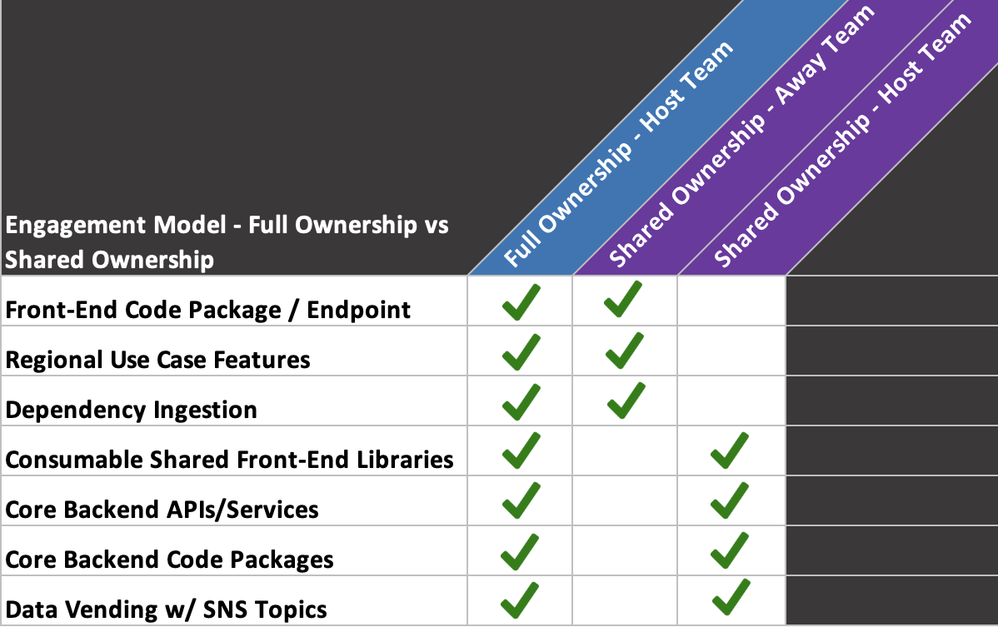

This support model is geared towards supporting regional business orgs that prefer to have NASC Tech core services extended to them for consumption. Regional business orgs would keep their funded headcount under their umbrella and focus on core features and Front-End development. NASC Tech would require less investment than the Direct Headcount Funding Model and focus more on making extendable services available and maintainable. This model does have an engagement contract that defines ownership areas (Appendix F – NASC Tech - Host Team Away Team Engagement Contract). Severity support is then based on agreed ownership areas.

Appendix F – NASC Tech - Host Team Away Team Engagement Contract
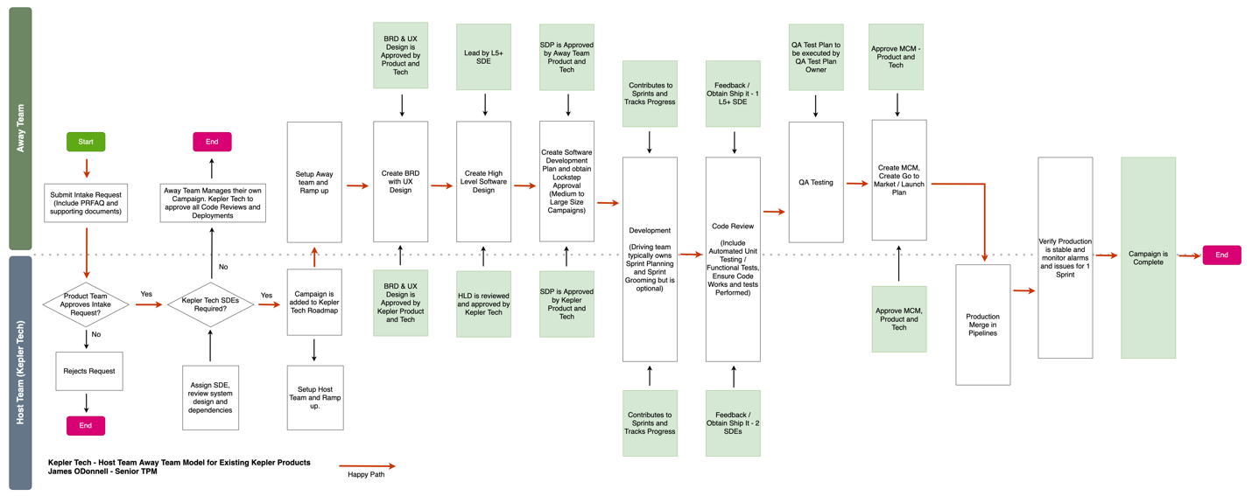
- Host Team
  - Provide Knowledge Transfer Training / Review Designs and Documentation for infrastructure and software packages
  - Provide access to code base for Away Team Engineers
  - All code reviews require 2 Host Team approvals before merging code
  - Host team is responsible for all code changes once fully approved
  - Leads independent Sprint Planning and shall align weekly with Away Team
  - Host team to build infrastructure that is extensible
  - Host team will not reject work that meets its own quality standards
  - Host team is responsible to own tasks that are most complex and impacts core services
  - Host team is not responsible for QA Test Plan or Go to Market Launch Tasks
  - Host team is responsible to merge code into Production Stage
- Away Team
  - Leads independent Sprint Planning and shall align weekly with Home Team
  - Away team shall engage and own tasks related to features
  - Away team requires a minimum of 1 Lead L5+ SDE to own/manage designs, code changes required and serve as main POC
  - Away team requires 1 Lead L5+ SDE approval on all away team CRs
  - Away team shall align on features, priorities and timing of deliverables
  - Will not commit to features that impact other regions
  - All code changes require a code review in CRUX
  - Away team is responsible for QA Test Plan and Go to Market Launch Tasks

Appendix G – Tech Contributors
Kepler Tech | James ODonnell, Ankit Patel, Shawn Van Ostrand, Nate Resue
EU Science and Tech | Hyung Lee, An Tian, Georgy Kutateladze, Guilhem Busset, Prashant Mudhalker, Prashant Mudhalkar
NA Product | Dhruvi Sinha, Justin Whitley
EU Product Tech | Julia Smirnova, Ulrich Bombka
EU ACES | Charly Schmidt
NA Kepler Tech Senior Leadership Sponsors | Hemant Nelaparthi, Hari Vijayaraghavan, Mike Feldman
EU Science & Tech Senior Leadership Sponsors | Georgios Paschos, Fabrizio Cairalli, Prashanth Dante, Simon Nusser

Appendix H – BRD Requirements First Pass
https://quip-amazon.com/Tx75Awlxdgl1/BRD-SARG-EU-2024-SDE-Requirement-Review

